**Medicine Recommendation System**

Submitted in partial fulfilment of the requirements

of the degree of

BACHELOR OF ENGINEERING

In

COMPUTER ENGINEERING

By

Group No: 11

Roll No.        Name

1404056      Nilesh Lalwani

1404060      Karan Makhija

1404068    Namrata Motwani

Supervisor:

PROF. ANAGHA DURUGKAR

(Assistant Professor, Department of Computer Engineering, TSEC)



Computer Engineering Department

Thadomal Shahani Engineering College

University of Mumbai

2017-2018

**CERTIFICATE**

This is to certify that the project entitled **“Medical Recommendation System”** is a bonafide work of

1404056 Nilesh Lalwani

1404060 Karan Makhija

1404068 Namrata Motwani

Submitted to the University of Mumbai in partial fulfilment of the requirement for the award of the degree of

**“BACHLEOR OF ENGINEERING” in “COMPUTER ENGINEERING”**

Guide

Ms. Anagha Durugkar

(Assistant Professor, TSEC)

Dr. Tanuja Sarode Dr. G.T. Thampi

Head of Department Principal

**ii.**

Project Report Approval for B.E

Project report entitled **“Medicine Recommendation System”** by

Roll No. Name

1404056 Nilesh Lalwani

1404060 Karan Makhija

1404068 Namrata Motwani

is approved for the degree of ***“BACHELOR OF ENGINEERING” in “COMPUTER ENGINEERING”****.*

Examiners

1.------------------

2.------------------

Date:

Place:

iii.

Declaration

We declare that this written submission represents my ideas in my own words and where others 'ideas or words have been included, we have adequately cited and referenced the original sources. We also declare that we have a adhered to all principles of academic honesty and integrity and have not misrepresented or fabricated or falsified any idea/data/fact/source in our submission. We understand that any violation of the above will because for disciplinary action by the Institute and can also evoke penal action from the sources which have thus not been properly cited or from whom proper permission has not been taken when needed.

Nilesh Lalwani, 1404056

Karan Makhija, 1404060

Namrata Motwani, 1404068

Date:

iv.

**Abstract**

We plan to develop a decision support system that helps patients select appropriate first-line medicines. The system allows the patients to protect themselves from infectious diseases by choosing the appropriate medicine. In an evaluation of the prototype system, it correlates each expensive medicine with its equivalent generic medicine. The system uses recommendation system algorithms to give user appropriate medicines and also correlates the user with another user having same health conditions to give better suggestions. The system is very effective and convenient for patients to use.

v.

**TABLE OF CONTENTS**

|  |  |  |
| --- | --- | --- |
| **Sr. No.** | **Topic** | **Page No.** |
|  | Abstract  List of Figures  List of tables | v  viii  ix |
| 1. | **Introduction**   * 1. Introduction   2. Aims & Objective   3. Scope | 1  1  2  2 |
| 2. | **Review of Literature**  2.1 Domain Explanation  2.2 Existing Solution  2.3 H/W & S/W requirement | 3  3  8  9 |
| 3. | **Analysis**  3.1 Functional Requirement  3.2 Non-Functional Requirement  3.3 Proposed System | 10  10  10  11 |
| 4. | **Design**  4.1 Design Details  4.2 Design Consideration  4.3 GUI Design | 12  12  19  20 |
| 5. | **Implementation** | 22 |
|  | 5.1 Plan for Implementation | 22 |
|  |  |  |
|  |  |  |
| 6. | **Conclusion** | 26 |
|  | References | 30 |
|  |  |  |

**List of Figures**

|  |  |  |
| --- | --- | --- |
| **Figure No.** | **Description** | **Page No.** |
| Figure 4.1 | Block Diagram | 12 |
| Figure 4.2 | Use case Diagram | 13 |
| Figure 4.3 | Activity Diagram | 14 |
| Figure 4.4 | Class Diagram | 15 |
| Figure 4.5 | Sequence Diagram | 16 |
| Figure 4.6 | State Chart Diagram | 17 |
| Figure 4.7 | Data Flow Diagram | 18 |
|  |  |  |

**Chapter1**

**Introduction**

* 1. **Introduction**

Increasing health information needs and changes in information seeking behaviour can be observed around the globe. According to recent studies 81% of U.S. adults use the Internet and 59% say they have looked online for health information regarding diseases, diagnoses and different treatments. Thus, patients tend to become active participants in the decision-making process. However, information overload and irrelevant information are major obstacles for drawing conclusions on the personal health status and taking adequate actions. Faced with a large amount of medical information on different channels (e.g., news sites, web forums, etc.) users often get lost or feel uncertain when investigating on their own. Therefore, improved personalized delivery of medical content can support users in finding relevant information.

Thus, the purpose of this project is to provide users the correct information about medicines. This is a recommendation system which recognizes and treats diseases by recommending the proper aid for it. Symptoms of the patient are taken as input and the proper treatment for it given as output.

* 1. **Aim and Objective**

Our project aims at making a system where consumers will be able to find health resources at many different levels. Levels such as:

* antibiotics
* herbal medicines
* vaccinations

Aiming to increase the use of generic medicines, which can be used as an alternate for the other higher priced medicines. Consumers should be aware of the side effects caused by the medicines they are prescribed for. The consumer should have adequate knowledge about the use and the effects of medicines. Enhancing the patient-physician relationship as the patient will have enough knowledge about the prescriptions and they can involve in a good debate with the physicians.

* 1. **Scope**

As part of achievable scope, we propose to create a system that takes as input the symptoms that the patient notices. Based on those symptoms proper medicines will be prescribed to the patients. Big Data Analytics is used to understand the symptoms. patient can also get the information about the alternate cheaper medicines.

**Chapter 2**

**Review of Literature**

* 1. **Domain Explanation**

**2.1.1 Big Data Analytics**

Big data analytics is the use of advanced analytic techniques against very large, diverse data sets that include different types such as structured/unstructured and streaming/batch, and different sizes from terabytes to zettabytes. Big data is a term applied to data sets whose size or type is beyond the ability of traditional relational databases to capture, manage, and process the data with low-latency. And it has one or more of the following characteristics – high volume, high velocity, or high variety. Big data comes from sensors, devices, video/audio, networks, log files, transactional applications, web, and social media - much of it generated in real time and in a very large scale.

Analysing big data allows analysts, researchers, and business users to make better and faster decisions using data that was previously inaccessible or unusable. Using advanced analytics techniques such as text analytics, machine learning, predictive analytics, data mining, statistics, and natural language processing, businesses can analyse previously untapped data sources independent or together with their existing enterprise data to gain new insights resulting in significantly better and faster decisions.

With the increasing production of information from various initiatives, there is also the need to transform a large volume of unstructured data into useful information for society. All this information should be easily accessible and made available in a meaningful and effective way to achieve semantic interoperability in electronic services. The concept of variety often underlies use of the term big data. Big Data refers to technologies and initiatives that involve data that is too diverse, fast-changing or massive for conventional technologies, skills and infra- structure to address efficiently. It’s about the ability to make better decisions and take meaningful actions at the right time.

Innovations in technology and greater affordability of digital devices have presided over today’s Age of Big Data, an umbrella term for the explosion in the quantity and diversity of high frequency digital data. The world is filled with data. Several other authors often refer to the “Three V’s” of big data: volume, variety, and velocity, originally discussed by Laney in 2001, to distinguish big data. Volume refers to the actual size of the dataset(s) analysed, variety to the various types of datasets possibly combined to produce new insights, and velocity to the frequency with which data is recorded and/or analysed for action. When trying to understand the concept of Big Data, the words “MapReduce” and “Hadoop” cannot be avoided.

**2.1.1.1 MapReduce**

MapReduce is a huge hit. Google faced with making sense of the largest collection of data in the world and took on this challenge. The result was MapReduce: a software framework that breaks big problems into small, manageable tasks and then distributes them to multiple servers. Google makes very heavy use of MapReduce internally, and the Apache Software Foundation turned to MapReduce to form the foundation of its Hadoop implementation. MapReduce can work with raw data that’s stored in disk files, in relational databases, or both. The data may be structured or unstructured, and is commonly made up of text, binary, or multi-line records. The most common MapReduce usage pattern employs a distributed file system known as Hadoop Distributed File System (HDFS).

Data is stored on local disk and processing is done locally on the computer with the data. The Hadoop Distributed File System (HDFS) is based on the Google File System (GFS) and provides a distributed file system that is designed to run on commodity hardware. HDFS holds very large amount of data and provides easier access. To store such huge data, the files are stored across multiple machines. These files are stored in redundant fashion to rescue the system from possible data losses in case of failure. HDFS also makes applications available to parallel processing.

At its core, MapReduce is composed of two major processing steps: Map and Reduce.

* The Map task takes a set of data and converts it into another set of data, where individual elements are broken down into tuples (key-value pairs).
* The Reduce task takes the output from the Map as an input and combines those data tuples (key-value pairs) into a smaller set of tuples. The reduce task is always performed after the map job.

**2.1.2 Recommendation System**

**2.1.2.1 Definition**

A recommendation system is a software program which attempts to narrow down selections for users based on their expressed preferences, past behaviour, or other data which can be mined about the user or other users with similar interests.

**2.1.2.2 Overview**

Recommendation systems have impacted or even redefined our lives in many ways. One example of this impact is how our online shopping experience is being redefined. As we browse through products, the Recommendation system offer recommendations of products we might be interested in. Regardless of the perspective — business or consumer, Recommendation systems have been immensely beneficial. And big data is the driving force behind Recommendation systems. A typical Recommendation system cannot do its job without sufficient data and big data supplies plenty of user data such as past purchases, browsing history, and feedback for the Recommendation systems to provide relevant and effective recommendations. In a nutshell, even the most advanced Recommenders cannot be effective without big data.

**2.1.2.4 How does a Recommendation system work?**

A Recommendation system works in well-defined, logical phases which are data collection, ratings, and filtering. These phases are described below.

**2.1.2.4.1 Data collection**

Let us assume that a user of Medicine Recommendation system is looking for some medicine details. Each time the user enters a name of medicine or enters the symptoms of a disease, an event such as an Ajax event could be fired. The event type could vary depending on the technology used. The entry is technical in content but in layman’s language could read something like “User A preferred (in case of symptoms) or looked-for medicine Z details once”. That is how user details get captured and stored for future recommendations.

How does the Recommendation system capture the details? If the user has logged in, then the details are extracted either from an http session or from the system cookies. In case the Recommendation system depends on system cookies, then the data is available only till the time the user is using the same terminal. Events are fired almost in every case — a user preferring a medicine or rating a medicine and providing reviews for it. So that is how user details are stored. But that is just one part of what Recommenders do.

**2.1.2.4.2 Ratings**

Ratings are important in the sense that they tell you what a user feels about a product. User’s feelings about a product can be reflected to an extent in the actions he or she takes such as likes, adding to shopping cart, purchasing or just clicking. Recommendation systems can assign implicit ratings based on user actions. The maximum rating is 5. For example, effective can be assigned a rating of 4, should work can get 3, preferring/clicking can get 2 and so on. Recommendation systems can also consider ratings and feedback users provide.

**2.1.2.4.3 Filtering**

Filtering means filtering products based on ratings and other user data. Recommendation systems use three types of filtering: collaborative, user-based and a hybrid approach. In collaborative filtering, a comparison of users’ choices is done and recommendations given. For example, if user X likes products A, B, C, and D and user Y Likes products A, B, C, D and E, the it is likely that user X will be recommended product E because there are a lot of similarities between user’s X and Y as far as choice of products is concerned. In user-based filtering, the user’s browsing history, likes, purchases and ratings are considered before providing recommendations.

**2.1.2.5 Role of big data**

As stated earlier, big data drives what Recommenders do primarily. Recommenders cannot do a thing without the constant supply of data. However, the role of big data goes beyond just data. The above operations require a high-capacity CPU which can work for hours. To realize this, Hadoop can be used.

So, the role of big data can be summed in providing meaningful, actionable data fast and providing necessary setup to quickly process the data. It is obvious that traditional technologies are not meant to process such large volumes of data so quickly. So, it will not suffice to just have big data to provide strong recommendations.

**2.1.2.6 Limitations of Recommendation systems**

* For all their efficiencies, Recommendation Systems are not a full proof system. Recommenders have been known to suffer from the following limitations:
* Recommenders depend totally on data and their hirers must constantly supply them with large volumes of data. That is why; smaller firms are more disadvantaged then the bigger firms such as Google and Amazon.
* Recommenders may find it difficult to exactly identify user choice patterns if the user preferences tend to vary quickly, as in fashion. Recommenders depend a lot on historic data but that may not be suitable for certain product niches.
* Recommenders face problems with unpredictable items. For example, there are certain movie types that evoke extreme reactions such as love or hate.
  1. **Existing Solution**
* MedicineNet is a medical website that provides detailed information about diseases, conditions, medications and general health. MedicineNet.com launched on October 17, 1996 William Shiel co-founded MedicineNet and continues today as the Chief Medical Editor. Melissa Stoppler also serves on the MedicineNet Editorial Board and she and Shiel were co-editors-in-chief of Webster's New World Medical Dictionary, Year 2008, Third Edition.
* MedicineNet is an owned and operated site in the [WebMD](https://en.wikipedia.org/wiki/WebMD) Consumer Network and was acquired by WebMD in December 2004. MedicineNet is a network of U.S. Board-Certified Physicians and Allied Health Professionals working together to provide the public with current, comprehensive medical information, written in easy to understand language.
* MedicineNet, as part of the WebMD Consumer Network, adheres to the same privacy policy as WebMD.com and is certified by the TRUSTe online privacy certification program. In addition, MedicineNet is HONcode certified to be in compliance with the Health on the Net health website principles.
* MedicineNet is ranked #5 in the January 2014 eBizMBA Top 15 Most Popular Health Websites

**2.3 H/W and S/W requirement**

The application requires certain hardware and software requirements to fulfil the needs of the project

They are as follows:

* + 1. **Hardware Requirements**

During Development:

* Windows XP enabled Computer
* RAM-2GB
* Hard Disk Space- a minimum of 1GB of space which is needed

During Usage:

* Windows XP7/VISTA enabled Computer
* RAM-2GB
* Hard Disk Space- minimum of 512 MB of free space which is required on system’s drive.
  + 1. **Software Requirements**

During Development:

* NetBeans/Eclipse, Web Browser, AWS (as a front end for GUI design)
* HTML, CSS, Java (as a programming language)

During Usage:

* HTML file of our system, Web Browser.
* Text pad (for taking as input the database from FLAT files)

**Chapter 3**

**Analysis**

**3.1 Functional Requirements**

* Search medicine according to symptoms.
* Search medicine according to medicine name.
* Can view alternatives for noxious medicines.
* Can view the dosage requirements of each medicine.
* The recommender system will provide knowledge about medication with excellent efficiency and scalability.

**3.2 Non-Functional Requirements**

* Learnability: A new user should be able to use the recommender engine without putting too much efforts, and, in case of doubt, there must be some help to solve their doubts.
* Reusability: The recommender engine should be reusable when someone wants to reuse and search for a different medicine.
* Performance: The recommender engine should generate recommendations within a time frame of 500 milliseconds.
* Reliability: Integrity and consistency of the recommender engine and all its transactions should be ensured.
* Correctness: The system should be able to predict results with a very small margin of error.
* Privacy: The privacy of the information provided by user should be guaranteed in the system.

**3.3 Proposed System**

We design and implement a universal medicine recommender system framework that applies Big Data technologies to the recommendation system. The medicine recommender system consists of database system module, data preparation module, recommendation model module and model evaluation. We investigate the medicine recommendation algorithms of the MapReduce algorithm, Collaborative Filtering algorithm and Content Based algorithm based on the diagnosis data.

Experiments are done to tune the parameters for each algorithm to get better performance. Finally, in the given open dataset, recommendation model is selected for the medicine recommendation module to obtain a good trade-off among model accuracy, model efficiency, and model scalability. We also propose a mechanism to recommend the medicine to a user based on another user with similar health conditions. Experimental results show our system can give medication recommendation with an excellent efficiency, accuracy and scalability.

**Chapter 4**

**Design**

**4.1 Design Details**

**Block Diagram**

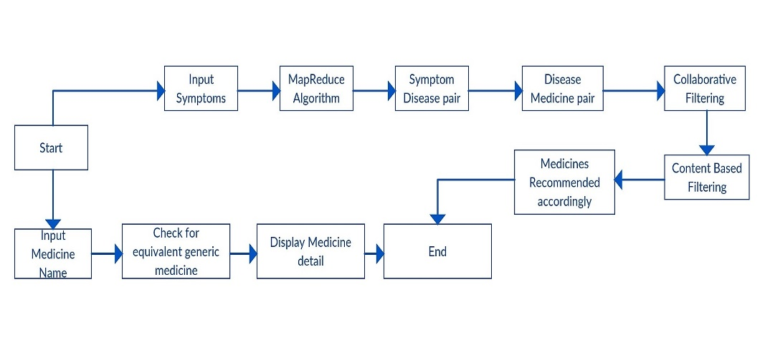

**Fig 4.1**

**4.1.1 Use Case Diagram**

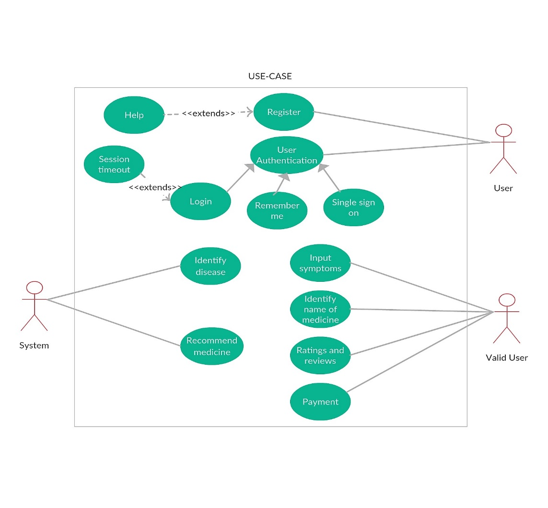

**Fig 4.2**

**4.4.2 Activity Diagram**

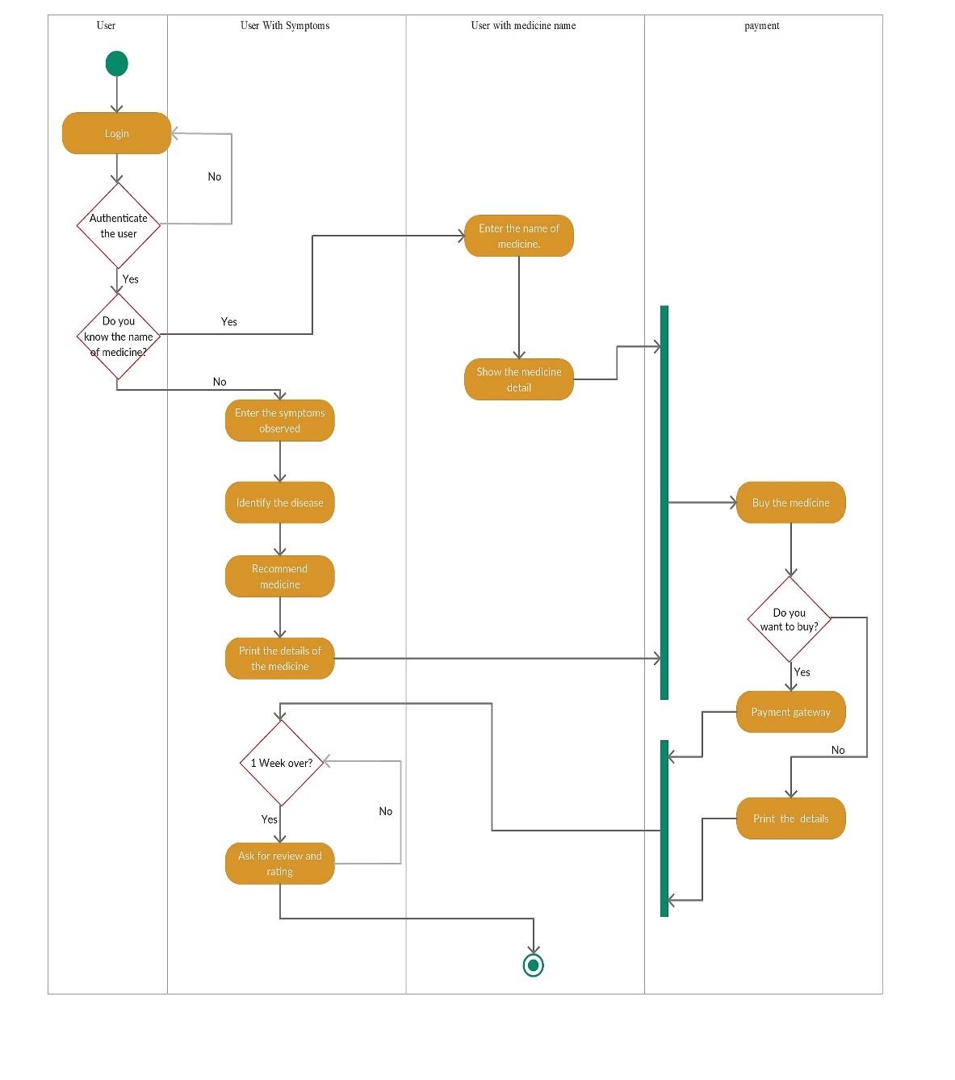

**Fig 4.3**

**4.4.3 Class Diagram**

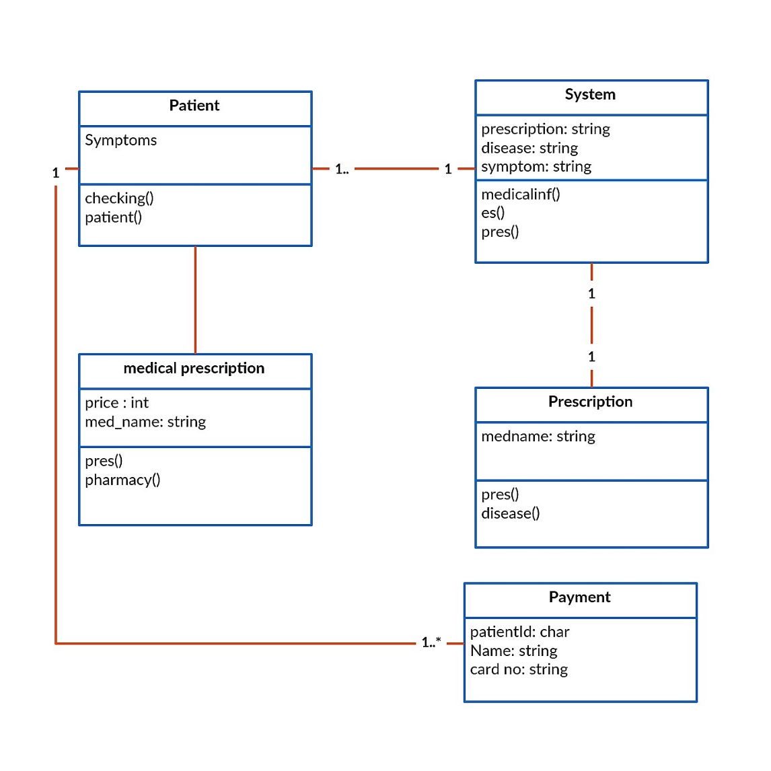

**Fig 4.4**

**4.4.4 Sequence Diagram**



**Fig 4.5**

**4.4.5 State Chart**

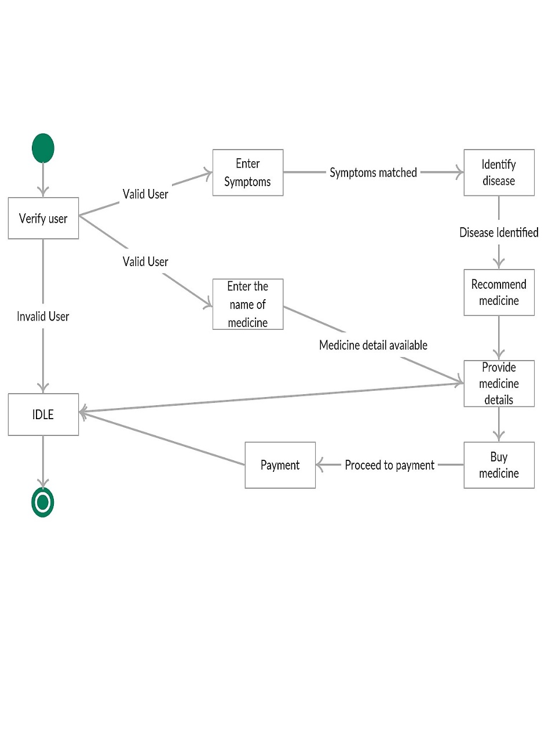

**Fig 4.6**

**4.4.6 Data Flow Diagram**

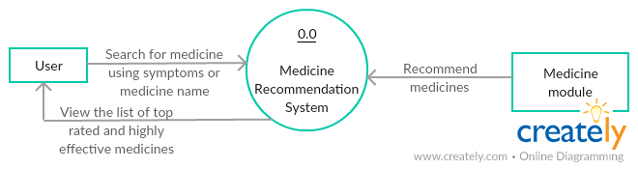

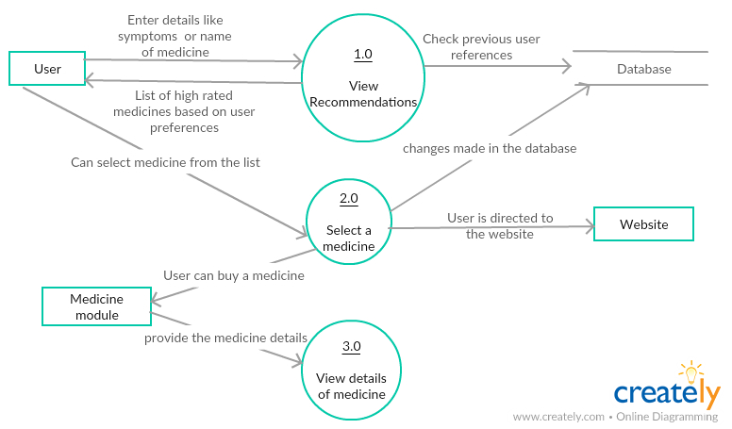

**Fig 4.7**

**4.2 DESIGN CONSIDERATIONS:**

* **Technology**: The technology is fast and scalable so that there are no bottlenecks in the future. Server speed and resources are optimised so that users can get an immediate response to their requests and there are no latencies.
* **Target audience**: The web app is designed and developed keeping in mind the target audience for our platform. The look and feel of the entire platform is simple, minimalistic and clean. All the design elements used have been beta tested for user feedback.
* **Navigability**: The entire platform has been designed to help the user navigate easily and quickly. Visual aids have been used wherever possible and content has been arranged in a linear fashion so that the user can understand the flow.
* **Usability**: The platform uses the principles of SPA (Single Page Application) so that all page’s load quickly. The website response time has been optimised for less than 3s so that users can get access to information fast and so that they don’t have to wait for too long.

**4.3 GUI Design**



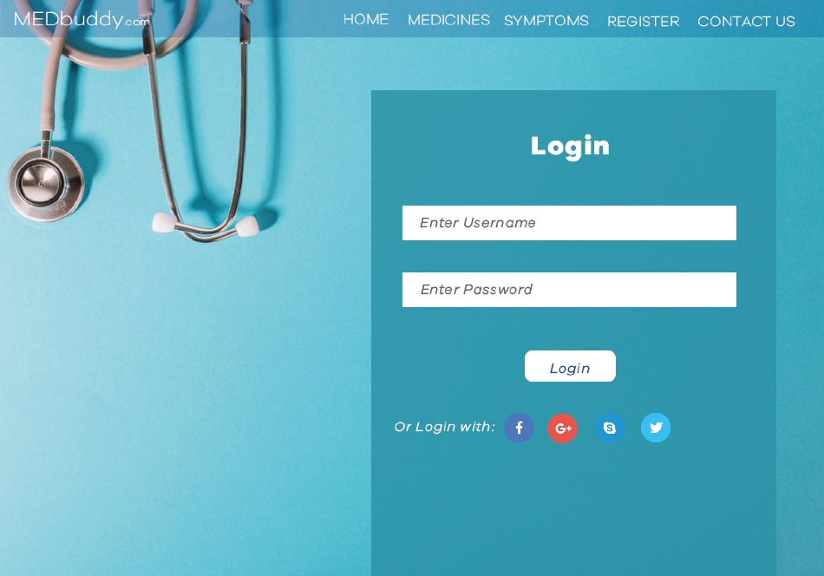

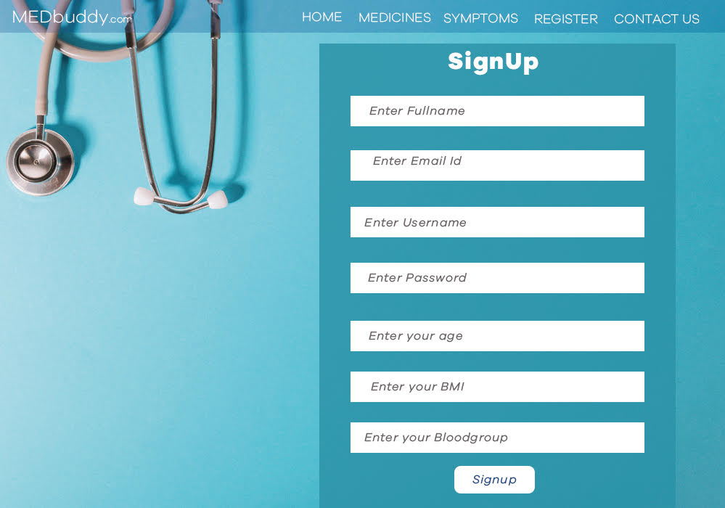

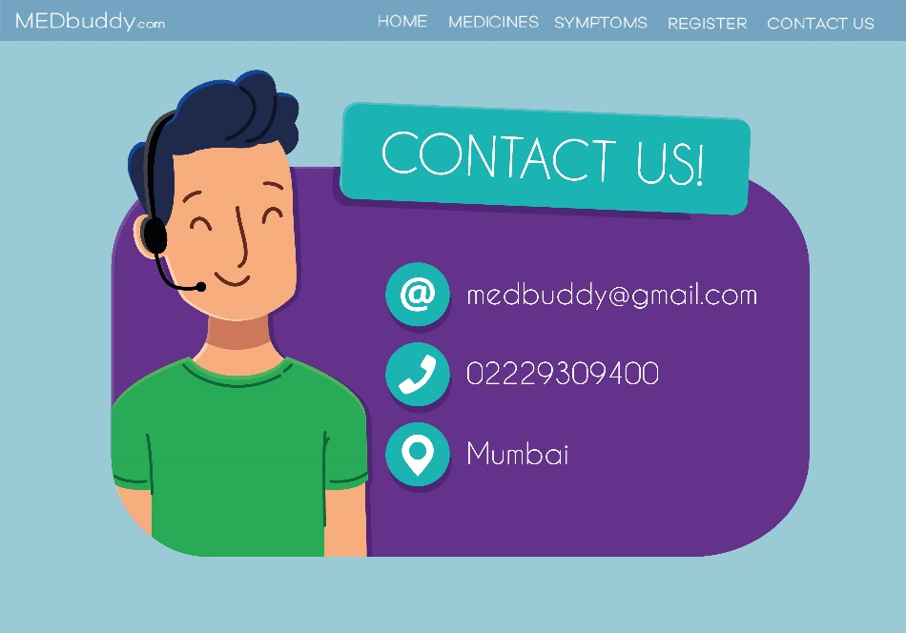

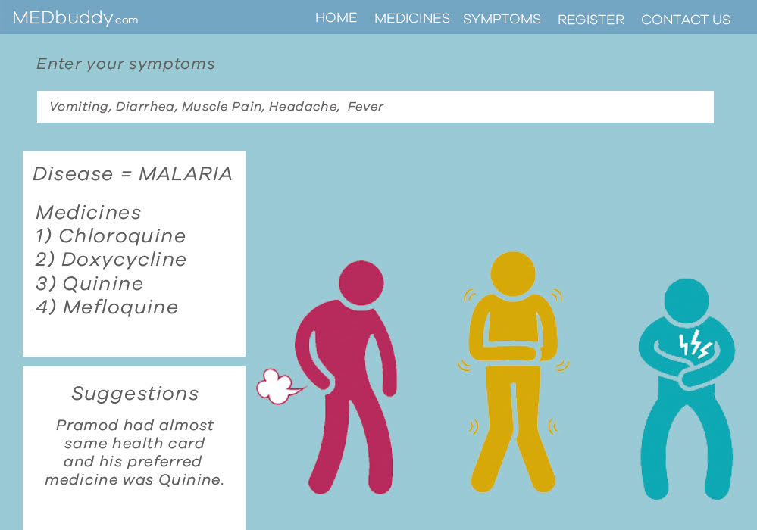

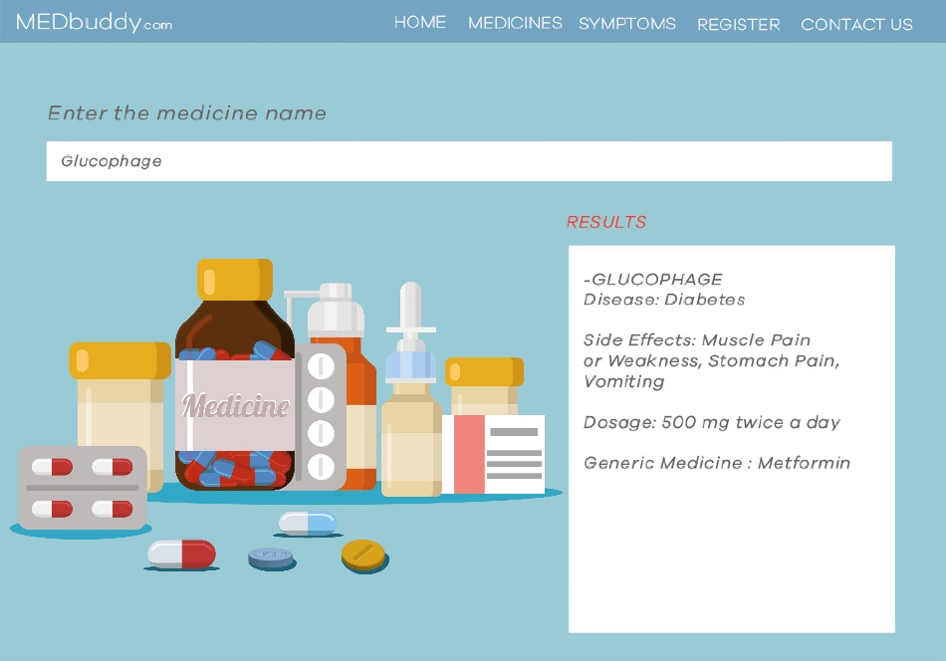

**References**

[1]. Nitin Agarwal, Ehtesham Haque, Huan Liu, and Lance Parsons, "Research Paper Recommender Systems: A Subspace Clustering Approach, " WAIM 2005, LNCS 3739, pp. 475-491, 2005.

[2]. Joseph Kramer, Sunil Noronha, John Vergo, "A User- centred design approach to personalization" Communications of the ACM, vo.43, Issue 8, pp.44-48, 2000.

[3]. Bamshad Mobasher, Honghua Dai, Tao Luo, Yuqing Sun and Jiang Zhu, "Integrating Web Usage and Content Mining for More Effective Personalization, " Electronic Commerce and Web Technologies LCNS, vo.1875, pp.165-176, 2000